1. Find the slope of the graphed line.
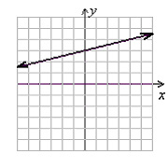
–4
-1/4
4
1/4

2. A man walks at a pace of 3 miles per hour. After 2 hours he stops for a rest. Let t be time AFTER the rest when he continues on his walk. Let d be the TOTAL distance traveled since he started. Write an equation linking d and t. . EXPLAIN WHAT YOU DID TO GET YOUR ANSWER!

3. A high school class wants to raise money by recycling newspapers. The class decided to rent a truck at a cost of $150 for the week. The market price for recycled newspapers is $15 per ton. Write an equation representing the amount of money the class will make based on the number of tons of newspapers collected. . EXPLAIN WHAT YOU DID TO GET YOUR ANSWER!

4. Bill is paid hourly. If he works 8 hours he will receive $50. Write an equation for his salary based on the number of hours he works. . EXPLAIN WHAT YOU DID TO GET YOUR ANSWER!

5. Complete the ordered pair ( , 4) so that it is a solution of x + 2y = 9.

6. Suppose y varies directly as x and that y = 21 when x =3. Find the value of y when x = 5

